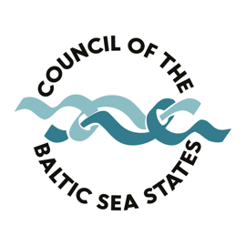
CBSS Summer University 2020

Application Form
Request for a partnership with the CBSS Secretariat

The CBSS Secretariat is ready to act as an Associate (unpaid) Project Partner for CBSS Summer Universities 2020 and provide support on following matters, namely, the CBSS logo, fund-raising, thematic input (speakers and contacts) and communication support.

- Name of the Lead and Partner Universities

- Experiences of the Lead University in organizing Summer Universities

- (Latest) contributions to the Baltic Sea Region related research

- The link between the Summer University and the long-term priorities of CBSS
- Theme/title, possible lectures and activities of the Summer University

- Please indicate expectations on how CBSS could be involved of planning the content of the programme?

- Possibility to provide European Academic credits (ECTS) to students - Yes/No

- A Place of Summer University

- Draft programme

- Expected results of the Summer University

- Draft budget and main donors. Please provide a short description on what fundraising support your institution is expecting to receive from the CBSS Secretariat. Kindly note that the CBSS Secretariat cannot provide direct financial support.

- Contact details of the person in charge (Name, Surname, position, e-mail,
tel. number)

